**Assignment 4: Web scraping from arXiv.org**

Step 1: visit the website <https://arxiv.org>

Step 2: provide “deep learning” in the search form with “Title” option

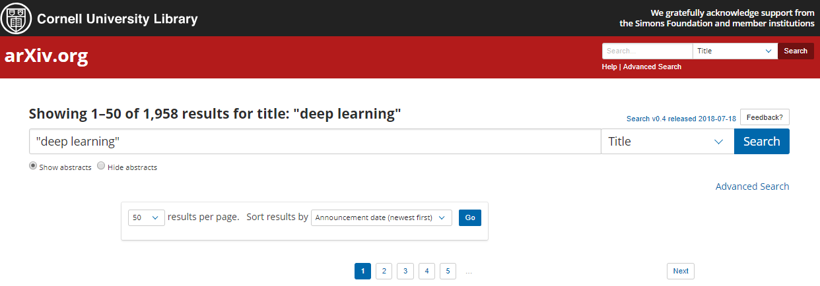

Step 3: Modify the provided script “04_3_Web Scraping_arXiv papers” as follows:

Step 3-1: Read the url of each paper from the first page to the last page

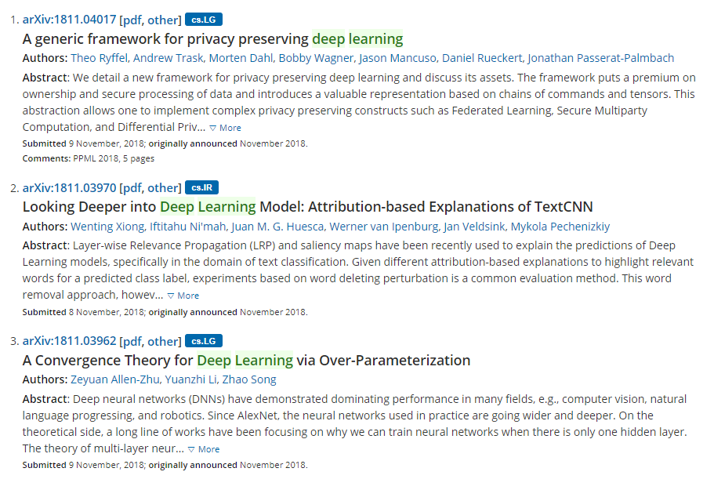

Step 3-2: Scrap the title, author, abstract, subject, and meta information by visiting the urls collected in Step 3-1 (You will earn extra credits if you collect the data from different parts of HTML source rather than from the same parts as in the provided script)

Step 4: Export the collected data with the file name “Deep learning arXiv papers.csv”